**SPRINT 5**

**REVIEW**



**Author: Imagineers Team**

**Date: 09/05/2017**

**Revision history**

|  |  |  |  |
| --- | --- | --- | --- |
| **Version** | **Date** | **Author** | **Notes** |
| **1.0** | 09/05/2017 | Thạch Nguyễn |  |
|  |  |  |  |
|  |  |  |  |

**TABLE OF CONTENT**

I. SPRINT 5- BACKLOG 4

II. SPRINT 5- BURNDOWN 4

III. SPRINT 5- TASK REPORT 5

IV. SPRINT 5- CHECKLIST 8

V. SPRINT 5- SUMMARY 10

# SPRINT 5- BACKLOG

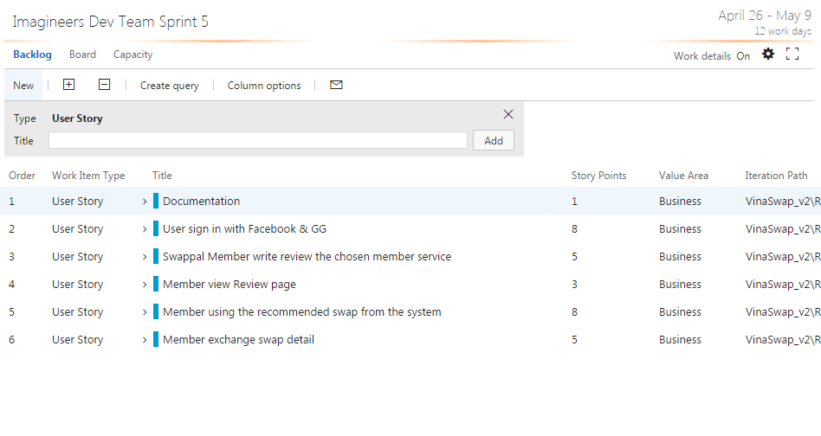

# SPRINT 5- BURNDOWN

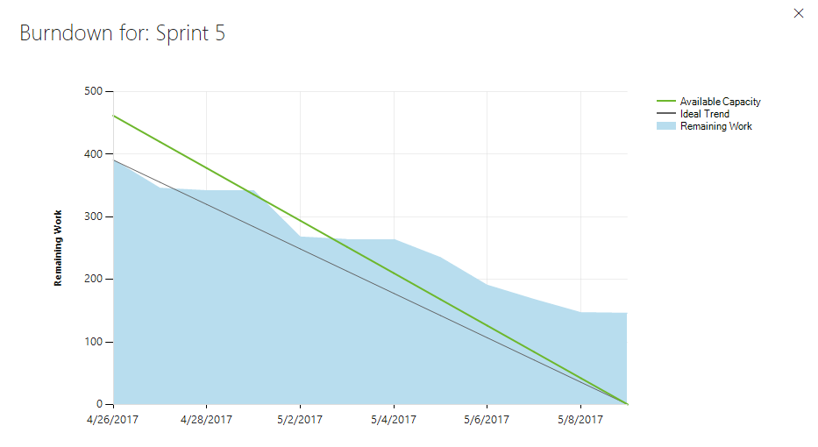

* Total estimated effort hours: 388 hours
* The actual effort hours: 215 hours
* The undone tasks hours: 173 hours

# SPRINT 5- TASK REPORT

|  |  |  |  |  |  |
| --- | --- | --- | --- | --- | --- |
| User story | Task | Assigned | Estimation (hrs) | Actual | Status |
| (hrs) |
| Documentation | Collect Sprint Artifact | Thach Nguyen | 5 | 3 | Done |
|  | Write sprint report | Thach Nguyen | 8 | 8 | Done |
| User sign in with Facebook | Code HTML/CSS | Quang Nguyen | 8 | 3 | Done |
|  | Code client side | Quang Nguyen | 16 | 11 | Done |
|  | Write functional test | Viet Dang | 3 | 6 | Done |
|  | Write Use Case – Sign in Facebook | Phuong Nguyen | 5 | 4 | Done |
|  | Write unit test – sign in facebook client side | Tai Nguyen | 8 | 8 | Done |
|  | Run unit test – sign in facebook client side | Tai Nguyen | 4 | 5 | Done |
|  | Build deploy | Thach Nguyen | 2 | 2 | Done |
|  | Design UI | Phuong Nguyen | 4 | 2 | Done |
|  | Write functional test | Viet Dang | 4 | 6 | Done |
|  | Run functional test | Viet Dang | 4 | 4 | Done |
|  |  |  |  |  |  |
| Swappal member write review | Design UI | Phuong Nguyen | 6 | 4 | Done |
|  | Run functional test | Viet Dang | 8 | 2 | Done |
|  | Code HTML/CSS | Quang Nguyen | 16 | 8 | Done |
|  | Write Use Case – write review | Phuong Nguyen | 2 | 1 | Done |
|  | Code client side – write review | Quang Nguyen | 16 | 5 | Undone |
|  | Code server side – write review | Chanh Tran | 12 | 7 | Undone |
|  | Write unit test – client side | Tai Nguyen | 8 | 4 | Done |
|  | Run unit test – client side | Tai Nguyen | 8 | 4 | Done |
|  | Write functional test case | Viet Dang | 2 | 4 | Done |
|  | Run functional test | Viet Dang | 4 | 5 | Undone |
|  | Write unit test – server side | Tai Nguyen | 8 | 8 | Undone |
|  | Run unit test – server side | Tai Nguyen | 8 | 4 | Undone |
|  | Run unit test –server side | Tai Nguyen | 4 | 3 | Done |
|  | Write Unit test –client side | Tai Nguyen | 8 | 6 | Done |
|  | Run Unit test –client side | Tai Nguyen | 4 | 3 | Done |
|  |  |  |  |  |  |
| Member view review | Code server side | Chanh Tran | 8 | 8 | Done |
|  | Write unit test – client side | Tai Nguyen | 6 | 6 | Done |
|  | Run unit test – client side | Tai Nguyen | 2 | 2 | Done |
|  | Write unit test – server side | Tai Nguyen | 8 |  | Undone |
|  | Write unit test – serve side | Tai Nguyen | 8 |  | Undone |
|  | Write functional test case | Viet Dang | 2 | 2 | Done |
|  | Run functional test | Viet Dang | 2 | 1 | Undone |
|  | Code client side | Quang Nguyen | 8 | 2 | undone |
| Member using recommended swap | Write unit test | Tai Nguyen | 8 | 2 | Done |
|  | Run unit test – client side | Tai Nguyen | 4 | 4 | Done |
|  | Write User case – using auto matched | Phuong Nguyen | 5 | 1 | Done |
|  | Build deploy product environment | Thach Nguyen | 4 | 2 | Done |
|  | Code HTML/CSS | Quang Nguyen | 8 |  | Undone |
|  | Code server side | Chanh Tran | 16 |  | Undone |
|  | Code client side | Quang Nguyen | 16 |  | Undone |
|  | Write functional test | Viet Dang | 4 | 5 | Done |
|  | Run functional test | Viet Dang | 2 | 2 | Done |
| Member exchange swap detail | Design UI | Phuong Nguyen | 8 | 5 | Done |
|  | Code HTML/CSS | Quang Nguyen | 8 | 6 | Done |
|  | Code client side – exchange swap | Quang Nguyen | 20 | 6 | Undone |
|  | Code server side – exchange swap | Chanh Tran | 20 | 8 | Undone |
|  | Write unit test – exchange swap client side | Tai Nguyen | 8 | 8 | Done |
|  | Run unit test – exchange swap client side | Tai Nguyen | 4 | 5 | Done |
|  | Write unit test – exchange swap server side | Tai Nguyen | 8 | 3 | Undone |
|  | Run unit test – exchange swap server side | Tai Nguyen | 4 | 3 | Undone |
|  | Write use case - exchange swap | Phuong Nguyen | 4 | 3 | Done |
|  | Run functional test – exchage swap | Viet Dang | 4 | 0 | Undone |
|  | Write functional test | Viet Dang | 4 | 1 | Undone |

# SPRINT 5- CHECKLIST

|  |  |  |  |
| --- | --- | --- | --- |
| Category | Detail | Artifacts | Status |
| User Story Clarity | User stories selected for the sprint are complete with respect to product theme, understood by the team, and have been validated by the detailed acceptance criteria. | Product backlog/ User story | Done |
| Tasks Identified | Tasks for selected user stories have been identified and estimated by the team. - |  | Done  Each story or task has ID  Task ID conduct on team service tool |
| Product owner approval | Each finished user story has been passed through UAT (User Acceptance Testing) and signed off as meeting requirements | References : Acceptance test | Imagineers-AcceptanceTest |
| Updating Product Backlog | All features not done during the sprint are added back to the product backlog. All incidents/defects not handled during the sprint are added to the product backlog. | Imagineers-BacklogRefinement | Done |
| Environment ready | Development environment is ready with all third-party tools configured.  Staging environment is ready.  Continuous integration framework is in place  Test data for the selected features has been created | Task management : Team service  Coding: Visual code  Document: Microsoft Office  Configuration tool: GitHub |  |
| Design complete | Design analysis is complete as per the user story or theme.  Prototype have been created and approved by the respective stakeholders.  Use cases are developed | Imagineers-Usecase  Imagineers-Prototype | Complete 100% story designs and use cases |
| Unit test cases written | Unit test cases have been written for the features to be developed |  | Developed :   * User sign in with Facebook * Swappal member write review |
| Documentation Ready | Documentation to support the sprint demo is ready |  |  |
| Code Complete | Source code changes are done for all the features in the “to do” list.” Source code has been commented appropriately. |  | Developed :   * User sign in with Facebook |
| Unit testing is done | Unit test cases have been executed and are working successfully |  | Developed :   * User sign in with Facebook |
| Code Refactoring | Source code has been refactored to make it comprehensive, maintainable and, amenable to change. |  | Done in GitHub |
| Code checkin | Source code is checked in the code library with appropriate comments added. |  | Done in GitHub |
| Code merging and tagging | Finalized source code has been merged with the main branch and tagged appropriately (merging and tagging guidelines are to be used) |  | Done in GitHub |
| Project metrics are ready | Burndown chart has been updated regularly and is up to date. |  | Burndown chart is developed |
| Functional testing done | Test team has reviewed and conducted necessary manual test cases to ensure that tests are passing. All incidents/defects are reported.  100% executed test cases and 80% test cases pass.  There are no major defect occurred  Accept 20% minor defects in layout or the defect doesn’t affect system | Imagineers-TestCase  Imagineers-TestReport | Done :   * User sign in with Facebook |
| Acceptance testing done | Each finished user story has been passed through UAT (User Acceptance Testing) and signed off as meeting requirements (see also Product Owner Approval). | Imagineers-AcceptanceTest | Acceptance test done :   * User sign in with Facebook |
| Closure | All finished user stories/tasks are marked complete/resolved. Remaining hours for task set to zero before closing the task. |  | There are a lot of undone task  Reference on III.Task Report |

# SPRINT 5- SUMMARY

* There are a lot of undone task leads to failure in done the stories ( Reference in III. Task Report)
* The undone stories is sent back to the backlog for further development
* Code checking and refactoring
* The size of sprint is too big, many big user stories.
* Team needs to fix this right away. If not it can cause the product to not finish on time